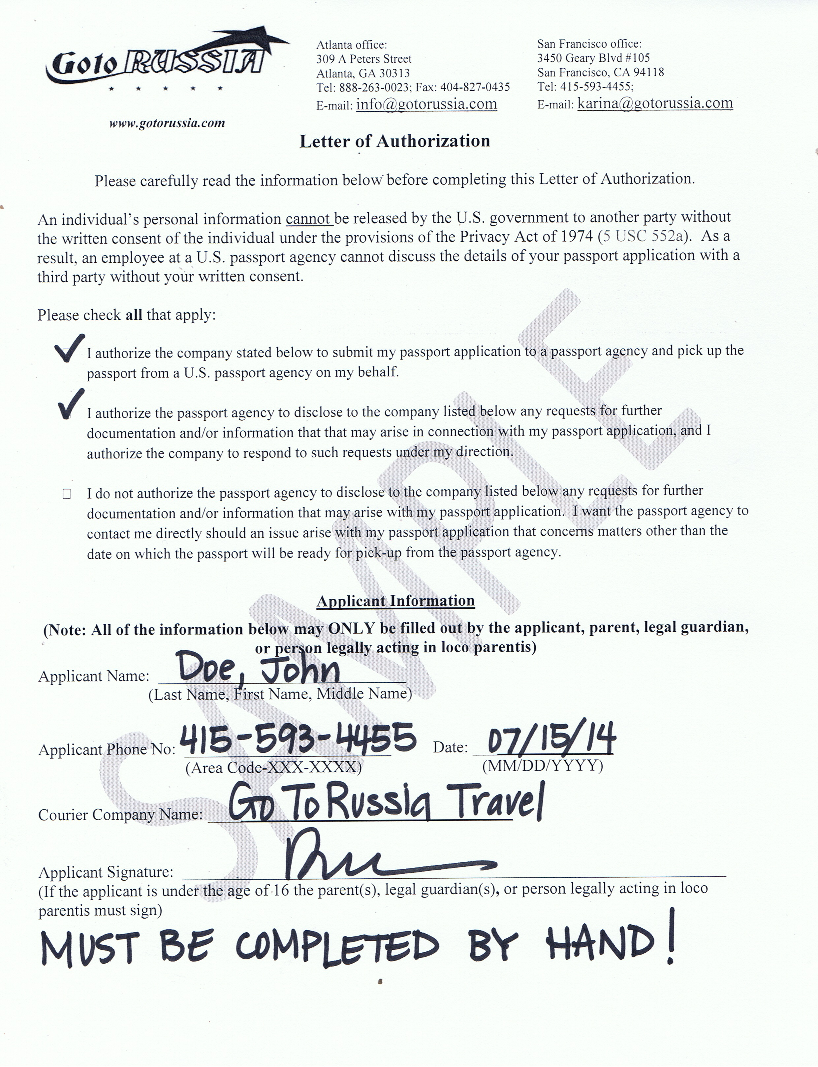
Letter of Authorization

Please carefully read the information below before completing this Letter of Authorization.

An individual’s personal information cannot be released by the U.S. government to another party without the written consent of the individual under the provisions of the Privacy Act of 1974 (5 USC 552a). As a result, an employee at a U.S. passport agency cannot discuss the details of your passport application with a third party without your written consent.

Please check all that apply:

- I authorize the company stated below to submit my passport application to a passport agency and pick up the passport from a U.S. passport agency on my behalf.

- I authorize the passport agency to disclose to the company listed below any requests for further documentation and/or information that that may arise in connection with my passport application, and I authorize the company to respond to such requests under my direction.

- I do not authorize the passport agency to disclose to the company listed below any requests for further documentation and/or information that may arise with my passport application. I want the passport agency to contact me directly should an issue arise with my passport application that concerns matters other than the date on which the passport will be ready for pick-up from the passport agency.

Applicant Information
(Note: All of the information below may ONLY be filled out by the applicant, parent, legal guardian, or person legally acting in loco parentis)
Applicant Name: ______________________________
(Last Name, First Name, Middle Name)

Applicant Phone No: _________________________ Date: _________________
(Area Code-XXX-XXXX) (MM/DD/YYYY)

Courier Company Name: _____________________________________

Applicant Signature: __________________________________________________________________
(If the applicant is under the age of 16 the parent(s), legal guardian(s), or person legally acting in loco parentis must sign)

